

Introduction to AI- powered Data Visualization Workshop

Submitted by
Name: Sumaiya Tasnim
Email ID: sumaiyaa.tasnim.18@gmail.com

AI Tools Used | POWER BI | ChatGPT Visualization Expert
Dataset link | https://www.kaggle.com/datasets/shivamb/netflix-shows | ChatGPT-generated dataset “Space_Mission.csv”
Project Name | Netflix Content Analytics Dashboard | Space Mission Analytics Dashboard

[Note: I used at least 2 AI-tools for “Dashboard Visualization” following requirements]

Access to all files:

Github Link: https://github.com/sumaiya-tasnim-18/Capstone-Projects/tree/main/2.%20Introduction%20to%20AI-%20powered%20Data%20Visualization%20Workshop

My AI- powered Data Visualization Workshop flow
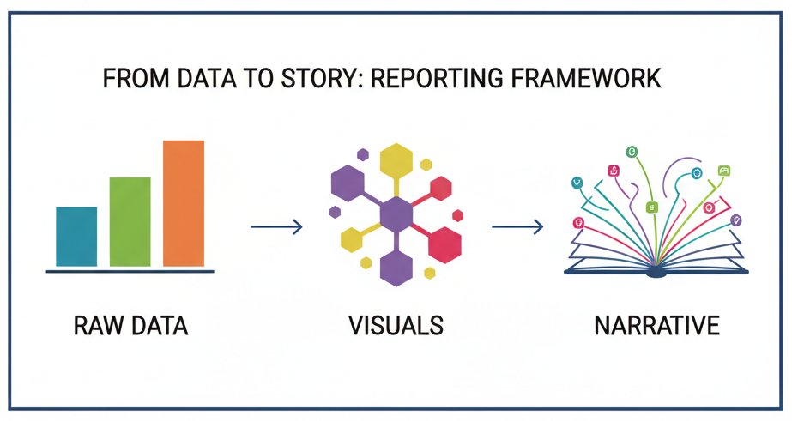

Dashboard Visualization in POWER BI

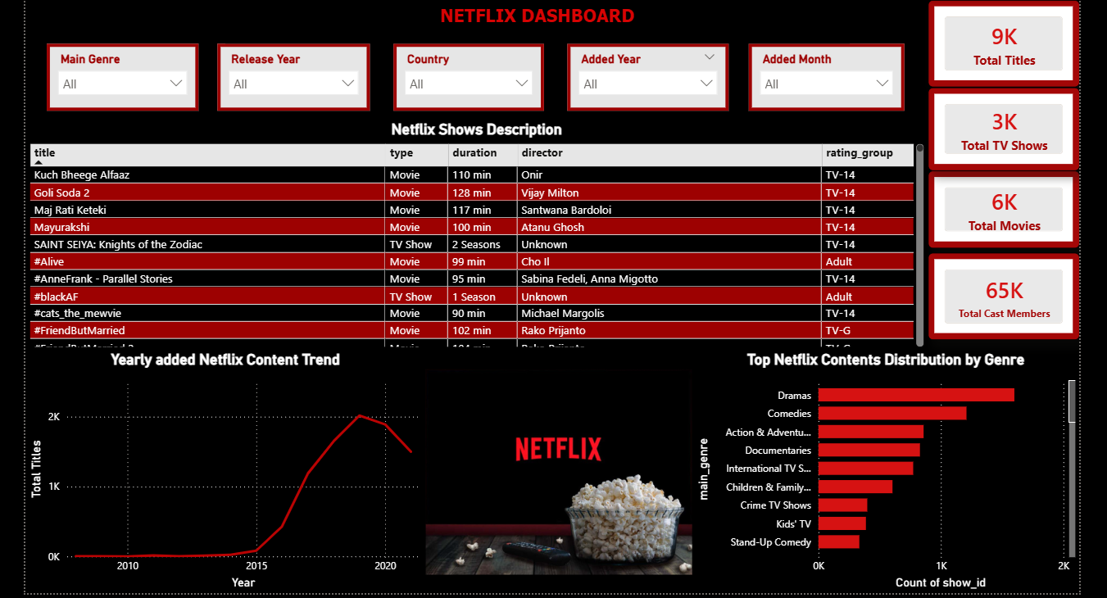

Netflix Content Analytics Dashboard — Narrative Summary
This dashboard provides a comprehensive analysis of Netflix content by combining key performance indicators, detailed descriptive visuals, and interactive filters that support deeper exploration. It offers a clear overview of how movies and TV shows are distributed across genres, how content has evolved over the years, and the characteristics of individual titles.

Overview of Key Metrics
The dashboard begins with four essential KPIs that offer an immediate snapshot of the Netflix catalogue:
Total Titles represents the complete count of movies and TV shows combined. Total Movies and Total TV Shows separately track the platform’s content distribution by category. Total Cast Members highlights the breadth of casting information available and reflects Netflix’s diversity of creative talent.
Together, these KPIs establish the overall scale of the dataset and set the foundation for further insights.

Interactive Filtering for Deep Exploration
Five filters—Main Genre, Release Year, Country, Added Year, and Added Month—allow users to dynamically slice the dataset and observe patterns across time, regions, and genres. These filters enhance the dashboard's analytical capability by making it possible to focus on specific genres, content release periods, or Netflix’s acquisition trends over time.
- Visual Insights
A. Netflix Shows Description (Matrix Table)
A matrix view displays detailed title-level information including title, type, duration, director, and rating group.
This section serves as an interactive content directory, enabling users to quickly access and compare key metadata for any movie or TV show.
B. Yearly Added Content Trend (Line Chart)
This line chart visualizes how many titles Netflix added each year, offering insight into growth patterns and acquisition behavior.
The upward or downward movements indicate shifts in Netflix’s content strategy—such as expanding into original productions, investing in specific genres, or adjusting regional licensing.
C. Content Distribution by Genre (Clustered Bar Chart)
This chart highlights the top genres on Netflix, sorted by the number of titles.
It quickly shows which categories dominate the platform—whether Comedies, Dramas, International content, or Documentaries—revealing Netflix’s strongest content segments.
- Insights & Value of the Dashboard
Overall, the dashboard provides a structured and interactive way to understand how Netflix builds its catalogue across genres, regions, and years.
Users can identify high-performing genres, analyze growth trends, explore rating patterns, and review individual title characteristics. The filter-rich design ensures flexibility, making the dashboard useful for market analysis, trend identification, and strategic content planning.

Dashboard Visualization in ChatGPT Visualization Expert
Space Mission Dataset (15 Rows) [This dataset was created by ChatGPT]
Mission | Country | Year | Launch_Site | Outcome | Cost_Million
Apollo 11 | USA | 1969 | Kennedy | Success | 355
Sputnik 1 | USSR | 1957 | Baikonur | Success | 90
Chandrayaan-1 | India | 2008 | SDSC | Success | 83
Rosetta | EU | 2004 | Guiana | Success | 1300
Viking 1 | USA | 1975 | Kennedy | Success | 1000
Giotto | EU | 1985 | Guiana | Success | 250
Mars 3 | USSR | 1971 | Baikonur | Partial | 450
SpaceX CRS-1 | USA | 2012 | Canaveral | Success | 133
Artemis I | USA | 2022 | Kennedy | Success | 4000
Luna 2 | USSR | 1959 | Baikonur | Success | 120
Hayabusa | Japan | 2003 | Tanegashima | Partial | 150
Beresheet | Israel | 2019 | Canaveral | Failure | 100
Tianwen-1 | China | 2020 | Wenchang | Success | 1600
JUICE | EU | 2023 | Guiana | Success | 1600
Chandrayaan-3 | India | 2023 | SDSC | Success | 75
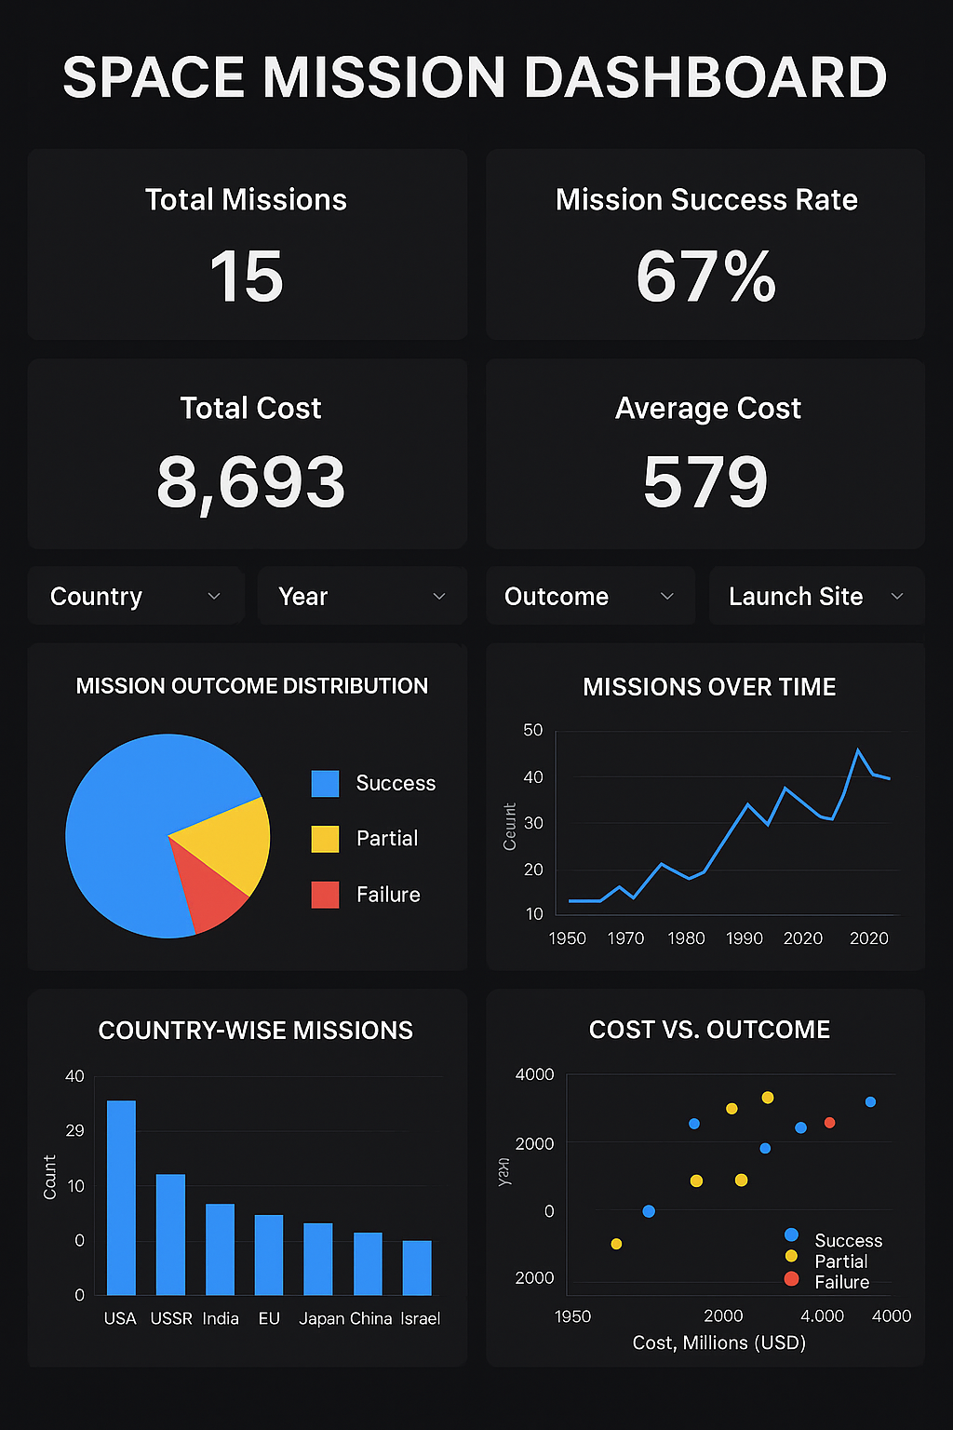

Space Mission Analytics Dashboard — Narrative Summary
The Space Mission Analytics Dashboard provides a focused, data-driven overview of global space exploration by combining key mission metrics, cost insights, country comparisons, and interactive filters. With its clean layout and mission-control themed visuals, the dashboard helps users understand historic and modern space missions across different nations, decades, and outcomes.
1. Overview of Key Metrics
The dashboard opens with four essential KPIs that present a quick snapshot of the entire space mission dataset:
Total Missions displays the complete count of 15 missions across seven countries. Mission Success Rate (%) quantifies the reliability of these missions, highlighting overall performance trends. Total Mission Cost aggregates the combined financial investment, offering an understanding of the scale and economic commitment in space exploration. Average Mission Cost shows the typical budget spent per mission, helping users compare low-budget and high-budget operations. Together, these KPIs set the stage by summarizing mission volume, success patterns, and cost distribution.
2. Interactive Filters for Deeper Analysis
The dashboard includes four slicers—Country, Year, Outcome, and Launch Site—that empower users to explore missions from multiple angles: Filtering by Country allows comparison between nations such as USA, USSR, India, EU, Japan, China, and Israel. The Year slicer enables trend exploration across decades ranging from 1957 to 2023. Outcome filtering (Success, Partial, Failure) helps users isolate mission performance. Launch Site selection provides insights into regional spaceport usage and geographic patterns. These filters make the dashboard highly interactive, allowing users to drill down into specific eras, countries, or mission categories.
3. Visual Insights
A. Mission Outcome Distribution (Pie Chart): This chart highlights the proportions of Successful, Partial, and Failed missions.It offers an instant understanding of mission reliability across the full dataset and helps compare performance across countries and decades.
B. Missions Over Time (Line Chart):The line chart showcases how global space missions have evolved from the 1950s to the 2020s. Users can observe spikes during major exploration periods, such as: Early USSR-USA competition, 2000s rise in multinational missions, Post-2020 modern exploration led by USA, India, EU, and China. This visual helps identify exploration trends and periods of rapid innovation.
C. Country-Wise Missions (Bar Chart): This chart compares the total missions conducted by each country. It clearly shows activity dominance—such as the strong presence of the USA and the USSR—while also showcasing emerging space nations like India, China, Israel, and Japan.
D. Cost vs. Outcome (Scatter/Bubble Chart): This visual relates mission cost to outcome, helping users understand whether higher investments lead to greater success.
Each dot represents a mission, color-coded by outcome and sized by cost, making it easier to compare successful high-budget missions (e.g., Artemis I) with lower-cost attempts.
These visuals extend the dashboard’s analytical depth by revealing spending patterns and spaceport usage frequency.
4. Insights & Value of the Dashboard
Overall, the Space Mission Analytics Dashboard provides a structured, interactive, and visually intuitive way to understand space exploration efforts across multiple decades and countries.
Users can: Compare mission success rates across nations, Explore how space exploration has grown over time, Analyze cost performance and identify high-value missions, Understand patterns in launch sites, mission outcomes, and technological progress. This dashboard is valuable for students, researchers, and analysts interested in historical spacemissions, budget efficiency, and comparative global space activity. Its blend of KPIs, layered visuals, and flexible filters makes it an effective analytical tool for storytelling and decision-making.

